Kubernetes 04

- Deploy an application using a Deployment with 3 replicas and a rolling update strategy.
Step 1: Create a Deployment YAML
vi rolling-deployment.yaml
apiVersion: apps/v1
kind: Deployment
metadata:
name: rolling-deployment
spec:
replicas: 3
strategy:
type: RollingUpdate
selector:
matchLabels:
app: nginx
template:
metadata:
labels:
app: nginx
spec:
containers:
- name: nginx
image: nginx:1.25
ports:
- containerPort: 80
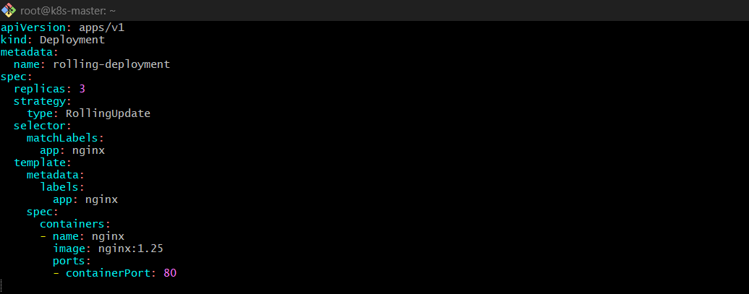
Step 2: Apply it
kubectl apply -f rolling-deployment.yaml
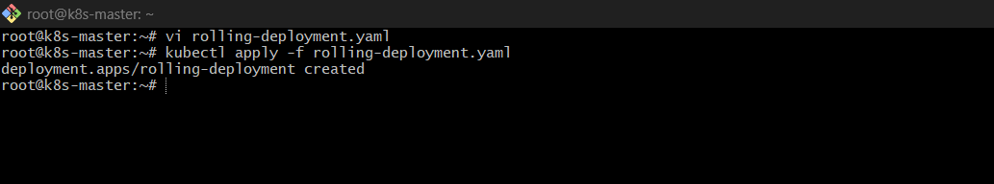
Step 3: Verify
kubectl get deployments
kubectl get pods
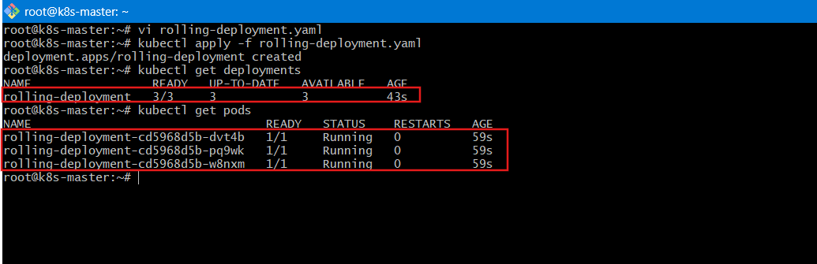
Explanation
- replicas: 3 → 3 Pods run simultaneously.
- RollingUpdate (default) → Pods update gradually, no downtime.
- Kubernetes replaces Pods one by one.

- Configure a Deployment with a Recreate strategy and observe the downtime.
Step 1: Create YAML
vi recreate-deployment.yaml
apiVersion: apps/v1
kind: Deployment
metadata:
name: recreate-deployment
spec:
replicas: 3
strategy:
type: Recreate
selector:
matchLabels:
app: recreate
template:
metadata:
labels:
app: recreate
spec:
containers:
- name: nginx
image: nginx:1.25
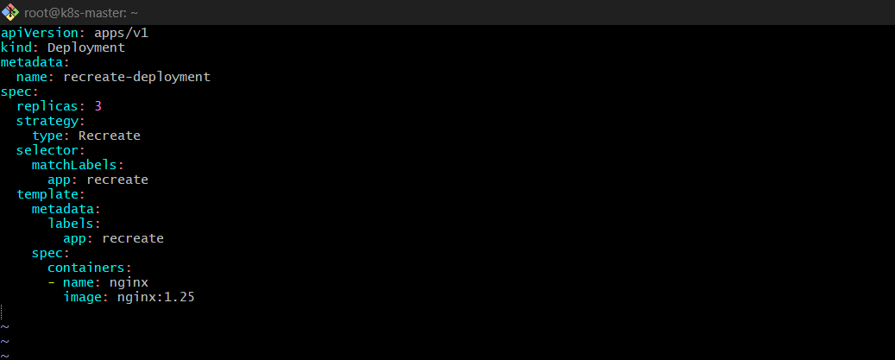
Apply it:
kubectl apply -f recreate-deployment.yaml
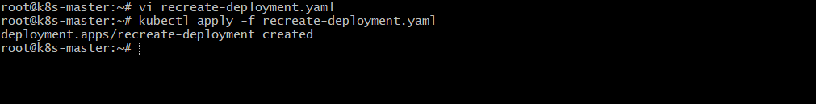
Step 2: Update Image
kubectl set image deployment/recreate-deployment nginx=nginx:1.26
Observe Pods
kubectl get pods -w
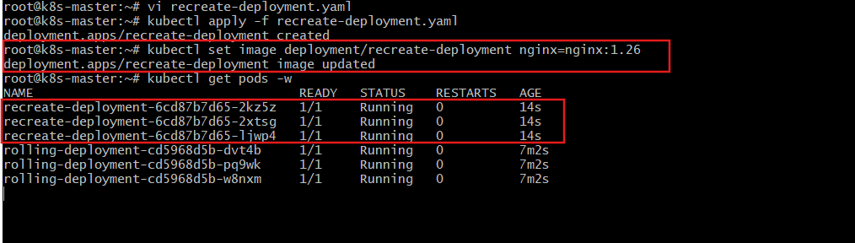
What Happens?
- All old Pods terminate first.
- Then new Pods are created.
- There is downtime between termination and recreation.

- Update an existing Deployment and perform a rollback to the previous version.
Update Deployment and Rollback
Step 1: Update Image
kubectl set image deployment/rolling-deployment nginx=nginx:1.26
Step 2: Check Rollout Status
kubectl rollout status deployment/rolling-deployment
Step 3: View Rollout History
kubectl rollout history deployment/rolling-deployment
Step 4: Rollback
kubectl rollout undo deployment/rolling-deployment
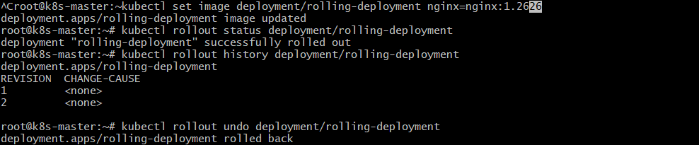
Step 4: See Deployments
kubectl get deplyoment
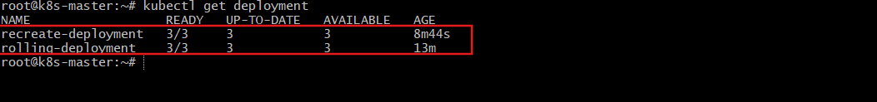
Explanation
- Kubernetes keeps ReplicaSet history.
- undo restores previous version instantly.

- Modify a Deployment to add resource requests and limits for CPU and memory.
Add Resource Requests and Limits
vi resource-nginx.yaml
Paste this configuration:
apiVersion: apps/v1
kind: Deployment
metadata:
name: resource-nginx
spec:
replicas: 2
selector:
matchLabels:
app: nginx-res
template:
metadata:
labels:
app: nginx-res
spec:
containers:
- name: nginx
image: nginx
resources:
requests:
memory: "128Mi"
cpu: "200m"
limits:
memory: "256Mi"
cpu: "500m"
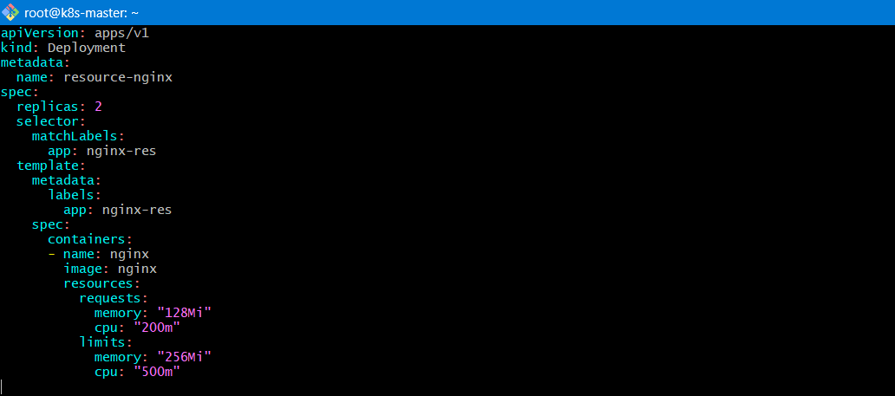
kubectl apply -f resource-nginx.yaml
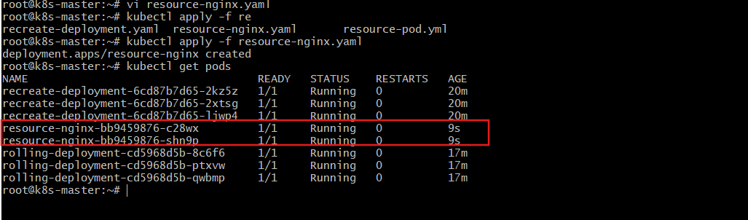
Verify:
kubectl describe resource-nginx-bbxxxx
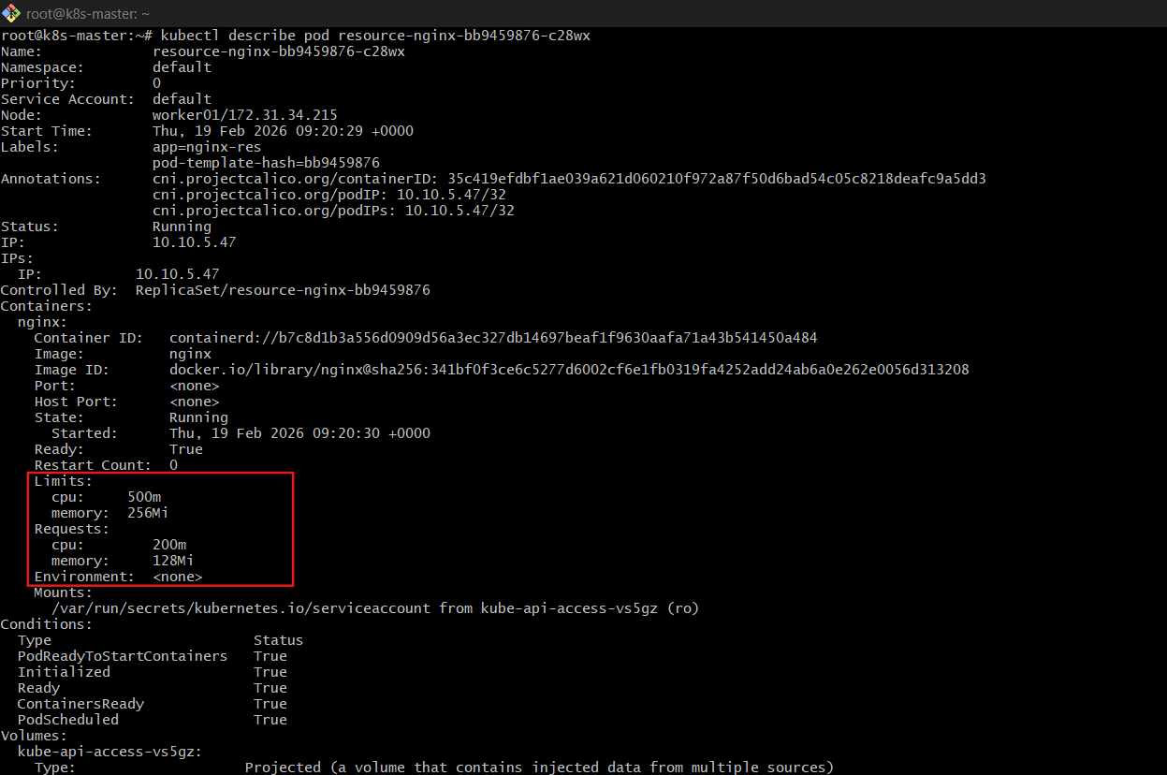
Explanation
Type | Purpose
requests | Minimum resources needed
limits | Maximum allowed
- Scheduler uses requests to place pods.
- Limits prevent overuse.

- Create a Deployment with MaxSurge and MaxUnavailable configurations.
Step 1: Create a Deployment YAML File
Create a file named:
vi surge-deployment.yaml
Paste the following configuration inside it:
apiVersion: apps/v1
kind: Deployment
metadata:
name: surge-deployment
spec:
replicas: 4
strategy:
type: RollingUpdate
rollingUpdate:
maxSurge: 1
maxUnavailable: 1
selector:
matchLabels:
app: surge
template:
metadata:
labels:
app: surge
spec:
containers:
- name: nginx
image: nginx:1.25
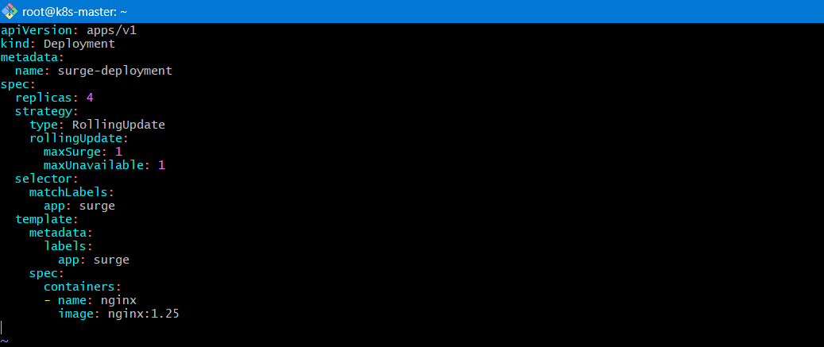
Step 2: Apply the Deployment
Run the following command:
kubectl apply -f surge-deployment.yaml
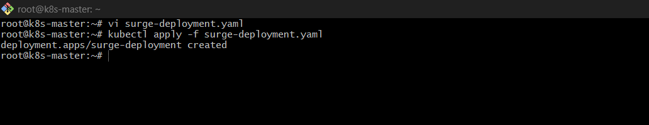
Step 3: Verify Deployment
Check the deployment status:
kubectl get deployments
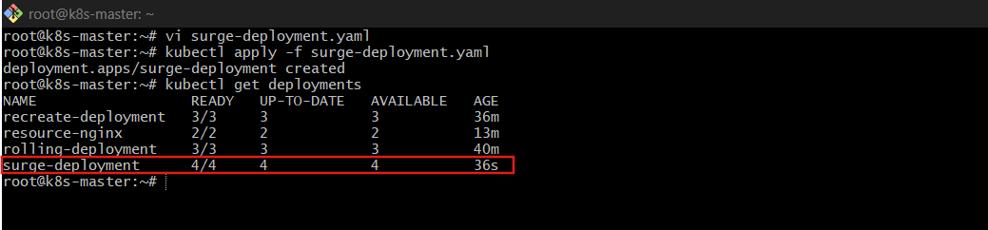
Check pods:
kubectl get pods
You should see 4 running pods.
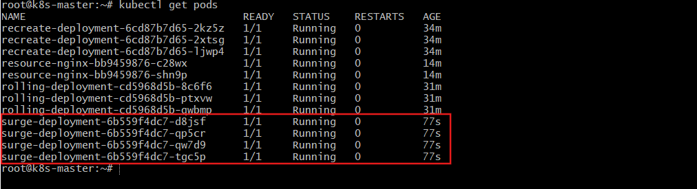
Step 4: Trigger a Rolling Update
Now update the image version to simulate an update.
Edit the deployment:
kubectl edit deployment surge-deployment
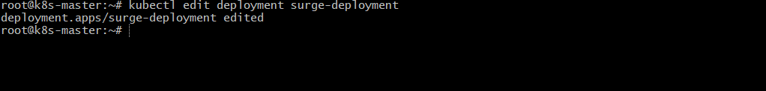
Change:
image: nginx:1.25
To:
image: nginx:1.26
Save and exit.
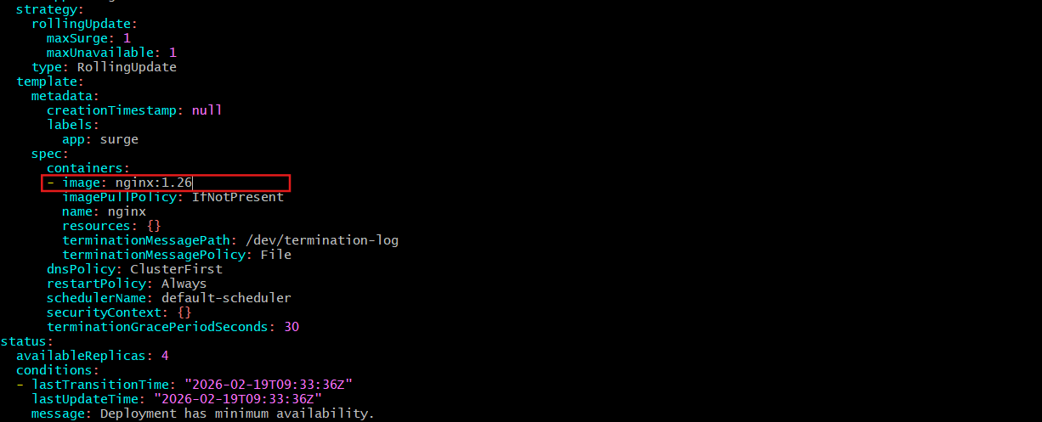
OR update using command: optional / alternative
kubectl set image deployment/surge-deployment nginx=nginx:1.26

- Set up a Deployment with a custom revision history limit.
Step 1: Create a YAML File
Create a file named:
vi revision-deployment.yaml
Add the following configuration:
apiVersion: apps/v1
kind: Deployment
metadata:
name: revision-deployment
spec:
revisionHistoryLimit: 2
replicas: 2
selector:
matchLabels:
app: revision
template:
metadata:
labels:
app: revision
spec:
containers:
- name: nginx
image: nginx
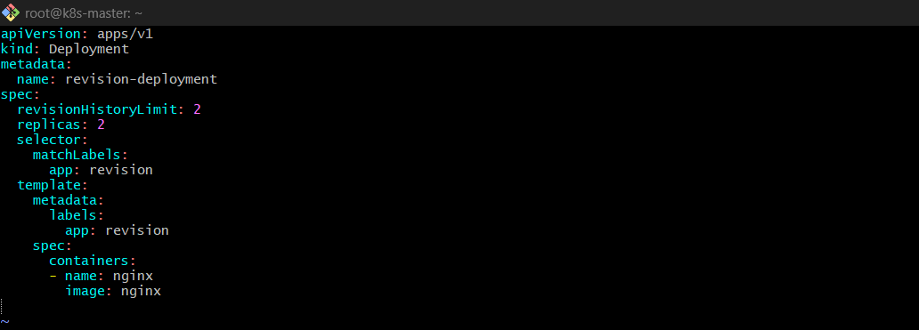
Step 2: Apply the Deployment
Run:
kubectl apply -f revision-deployment.yaml
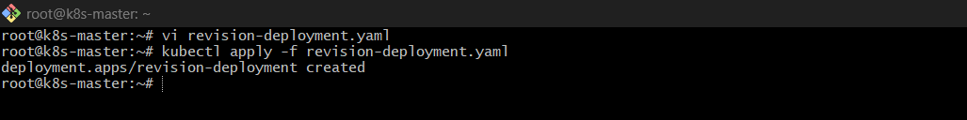
Step 3: Verify Deployment
Check deployment:
kubectl get deployment
Check ReplicaSets:
kubectl get rs
Initially, you will see 1 ReplicaSet.
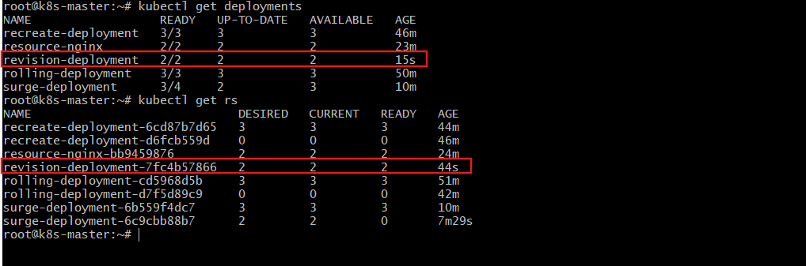
Step 4: Create Multiple Revisions (Updates)
Now update the image multiple times to create new revisions.
Update 1:
kubectl set image deployment/revision-deployment nginx=nginx:1.25
Update 2:
kubectl set image deployment/revision-deployment nginx=nginx:1.26
Update 3:
kubectl set image deployment/revision-deployment nginx=nginx:1.27
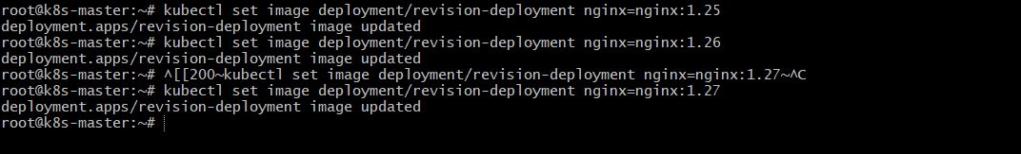
✅ Step 5: Check Revision History
View rollout history:
kubectl rollout history deployment revision-deployment
Check ReplicaSets again:
kubectl get rs
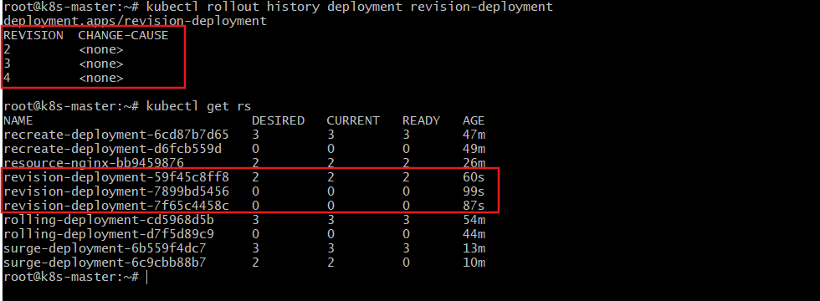
You will notice:
- Only 2 old ReplicaSets are retained
- Older ReplicaSets are automatically deleted
- Total ReplicaSets kept = current + last 2

- Pause a Deployment during an update and then resume it.
Step 1: Check Current Deployment
First, verify deployment exists:
kubectl get deployments
Check current image:
kubectl describe deployment rolling-deployment | grep Image
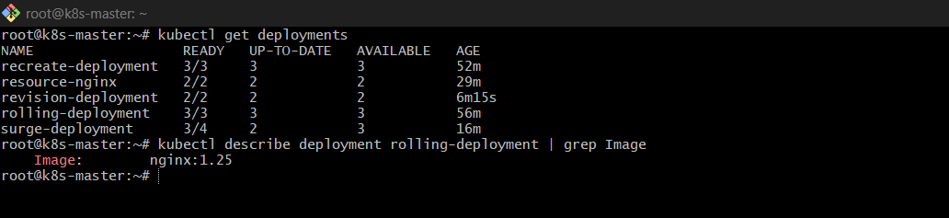
Step 2: Pause the Deployment
Run:
kubectl rollout pause deployment/rolling-deployment
Verify pause status:
kubectl rollout status deployment/rolling-deployment
It will indicate the deployment is paused.
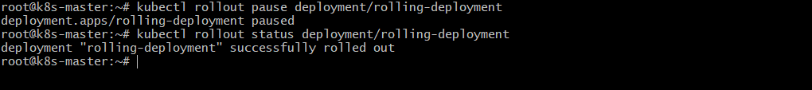
Step 3: Update the Image (While Paused)
Now update the image:
kubectl set image deployment/rolling-deployment nginx=nginx:1.27
Output:
deployment.apps/rolling-deployment image updated
Now check pods:
kubectl get pods
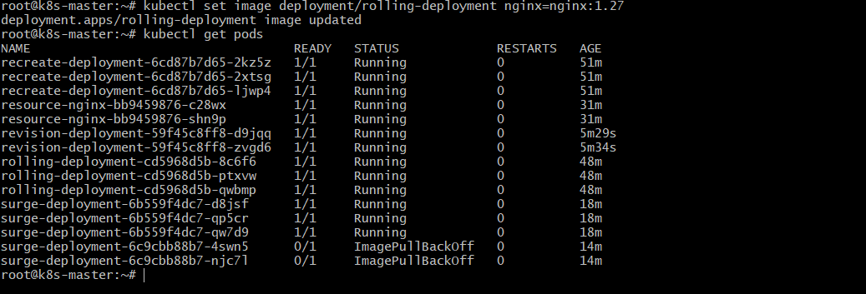
You will notice:
- Pods are NOT updating
- No new ReplicaSet rollout happens
- Because deployment is paused

Step 4: Resume the Deployment
Run:
kubectl rollout resume deployment/rolling-deployment
Output:
deployment.apps/rolling-deployment resumed
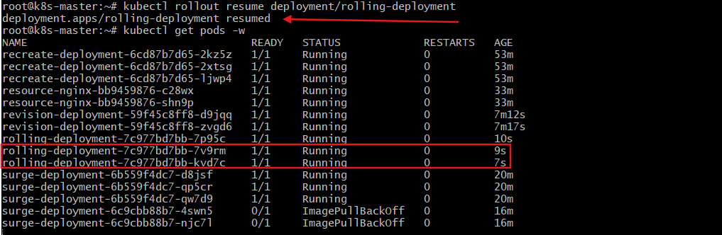
Step 5: Watch the Update
kubectl get pods -w
Now rollout starts:
- New pods created
- Old pods terminated
- Rolling update begins

- Create a pod using resource requests for memory and CPU and observe how the scheduler assigns it to a node.
Create Pod with Resource Requests (Observe Scheduling)
Step 1: Create Pod YAML
vi resource-pod.yaml
apiVersion: v1
kind: Pod
metadata:
name: resource-pod
spec:
containers:
- name: stress
image: nginx
resources:
requests:
memory: "500Mi"
cpu: "500m"
limits:
memory: "1Gi"
cpu: "1"
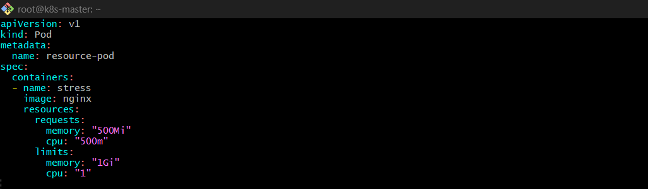
Apply:
kubectl apply -f resource-pod.yaml
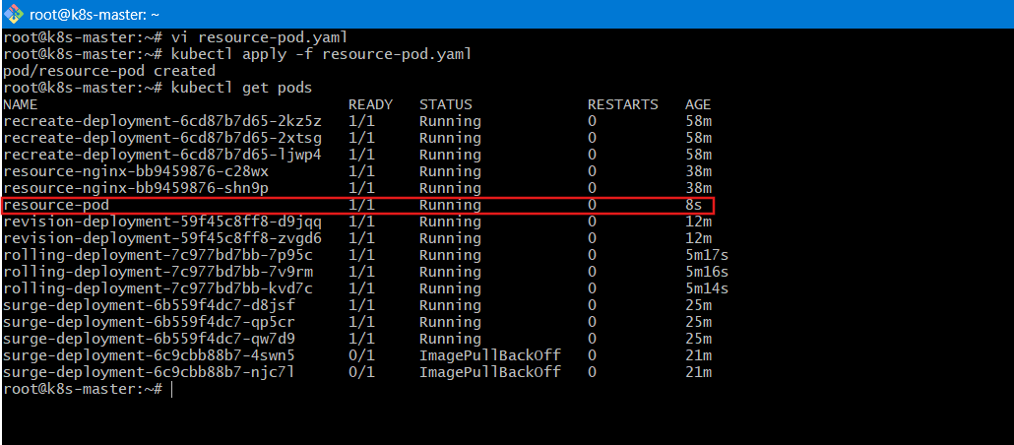
Step 2: Check Node Assignment
kubectl get pod resource-pod -o wide
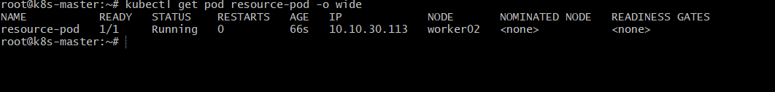
Explanation
- Scheduler checks available node capacity.
- If no node satisfies request → Pod stays Pending.
- kubectl describe pod resource-pod shows scheduling details.

